**(CANCER OF THE EYE)**

***THE GLOW YOU MUST KNOW***

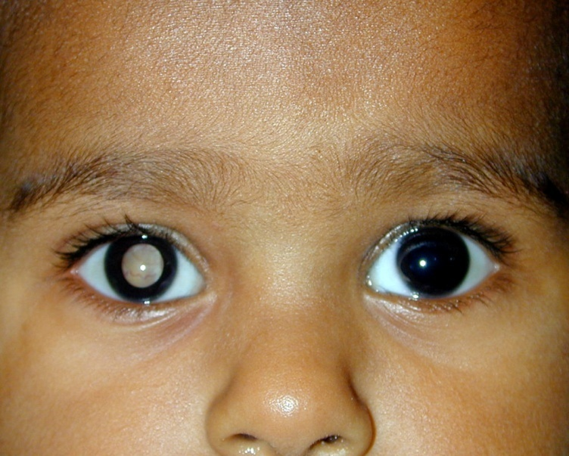

**WHAT IS RETINOBLASTOMA?**

Retinoblastoma is an eye cancer which affects young children. The retinoblastoma tumor originates from the retina, the light sensitive layer of the eye which enables us to see. Retinoblastoma affects children of all races and both boys and girls. When the tumor is present in on eye, it is referred to as unilateral retinoblastoma, and when it occurs in both eyes, it is referred to as bilateral retinoblastoma. In one third of affected children, the tumor develops in both eyes.

**HOW COMMON IS RETINOBLASTOMA?**

Retinoblastoma is the most common eye cancer in children, with a reported incidence of 1 in 20,000 live births. It is estimated that worldwide, 7000 children with retinoblastoma are diagnosed every year. India accounts for the highest number of retinoblastoma cases in the world. This eye cancer is usually seen in children who are below 5 years of age, although rarely, it may be seen in older children also.

**WHY DOES IT OCCUR?**

Retinoblastoma is a genetic disease caused by an abnormality in chromosome 13, in which a part of the chromosome is non-functional or missing. Chromosome 13 is responsible for controlling retinal cell division. In children with retinoblastoma, retinal cell division continues unchecked, causing the retinal tumor. In 40% cases, the abnormality is present in every cell of the body including the eye, whereas in 60% cases, the abnormality is found only in the eye.

**WHAT ARE THE SYMPTOMS?**

Retinoblastoma can present in a variety of ways. The majority of children present with a white reflection in the pupil (leucocoria) instead of a normal black pupil. This abnormal white papillary reflex is also known as a cat’s eye reflex. Other eye diseases can also present with a similar white papillary reflex and an eye examination is required to make a correct diagnosis. A crossed eye or strabismus is the second most common manner in which retinoblastoma can present. Other symptoms include a red and painful eye or poor vision. In cases with delayed presentation, swelling and outward bulging of the eye can occur. On rare occasions, retinoblastoma may be discovered on a routine examination. Most often, the symptoms of retinoblastoma are first detected by a parent or a family member who notice leucocoria or squint and bring their child to the ophthalmologist.

**HOW IS THE DIAGNOSIS CONFIRMED?**

A combination of clinical examination and investigations are used to establish the diagnosis of retinoblastoma.

1. **Examination under Anesthesia**

Children are often uncooperative for examinations. Hence, general anesthesia may be required in many cases for a thorough clinical examination. The ophthalmologist carries out a detailed examination of the eye. Images of the retina are taken to document the tumor.

1. **Investigations**

Ultrasound examination of the eye is done to confirm the presence of retinoblastoma. Ultrasound is especially useful in cases where the tumor is large and the retina cannot be visualized. In some cases CT scan of the orbits may be advised. Magnetic Resonance Imagig (MRI) of the orbits and the brain is performed in advanced cases to see if the tumor has spread outside the eyeball. A consultation with a pediatric oncologist( specialist who deals with childhood cancers) is arranged who performs a physical examination and blood tests to see if the tumor has spread to other parts of the body. Other tests advised by the pediatric oncologist include a chest X-ray, ultrasound of the abdomen, examination of the bone marror tissue and the fluid that surrounds the spine.

**IS RETINOBLASTOMA CURABLE?**

Yes, fortunately retinoblastoma is a curable cancer. The treatment is individualized for each patient, and depends upon the stage of the tumor, status of vision in the affected eye, the involvement of one or both yes and whether or not the cancer has spread to other parts of the body. The main therapeutic goals include saving the life of the child, saving the eye, preserving vision and imparting a good cosmetic appearance to children in whom removal of the eye is needed as a life-saving measure.

**HOW CAN THE EYE BE SAVED?**

It is possible to save the eye provided the tumor is detected at an early stage. The various treatment modalities available are laser therapy or thermotherapy, cryotherapy(Freezing the tumor),chemotherapy and radiation therapy. Depending upon the severity of tumor, each type of treatment can be used alone or in combination. Enucleation (removal of the eye) is performed only if other therapies do not work well or when the tumor is detected at a later stage and there is no potential for vision in the affected eye.

**CAN THE EYE BE REPLACED BY ANOTHER EYE?**

Unfortunately, there is currently no procedure available to replace the entire eye. There is a misconception among some available people that the removed eye can be replaced by a donor eye. During enucleation, the whole eye is removed along with the tumor, leading to irreversible loss of vision. Good quality, custom-made artificial eyes are readily available that aim to provide the best possible cosmetic outcome to the child

**CAN THE CHILD LEAD A NORMAL LIFE?**

Yes. The majority of children survives the cancer and has normal lives. They grow up and become successful in various fields. It is important for children with vision in only one eye to wear protective glasses during sports and other hazardous activities. The majority of children with both eyes affected retain at least one eye with good vision after treatment.

**Did you know?**

* Retinoblastoma is the most common eye cancer in children
* It is usually seen in children below 5 years of age
* Retinoblastoma is a curable…..Early diagnosis is the key.
* Any delay in treatment is life threatening.

**TO SUMMERAISE**

**Symptoms of Retinoblastoma**

* A White reflection in the eye
* An eye looking inwards or outwards
* Swelling or redness of the eye
* Deterioration in vision

**Treatment Options**

* Thermotherapy-use of heat to destroy cancer cells
* Laser- use of laser light to destroy blood vessels that supply blood to the tumor
* Cryotherapy- use of extreme cold to destroy cancer cells
* Radiation therapy- use of radiation to kill cancer cells
* Enuclation- removal of the eye affected by tumor